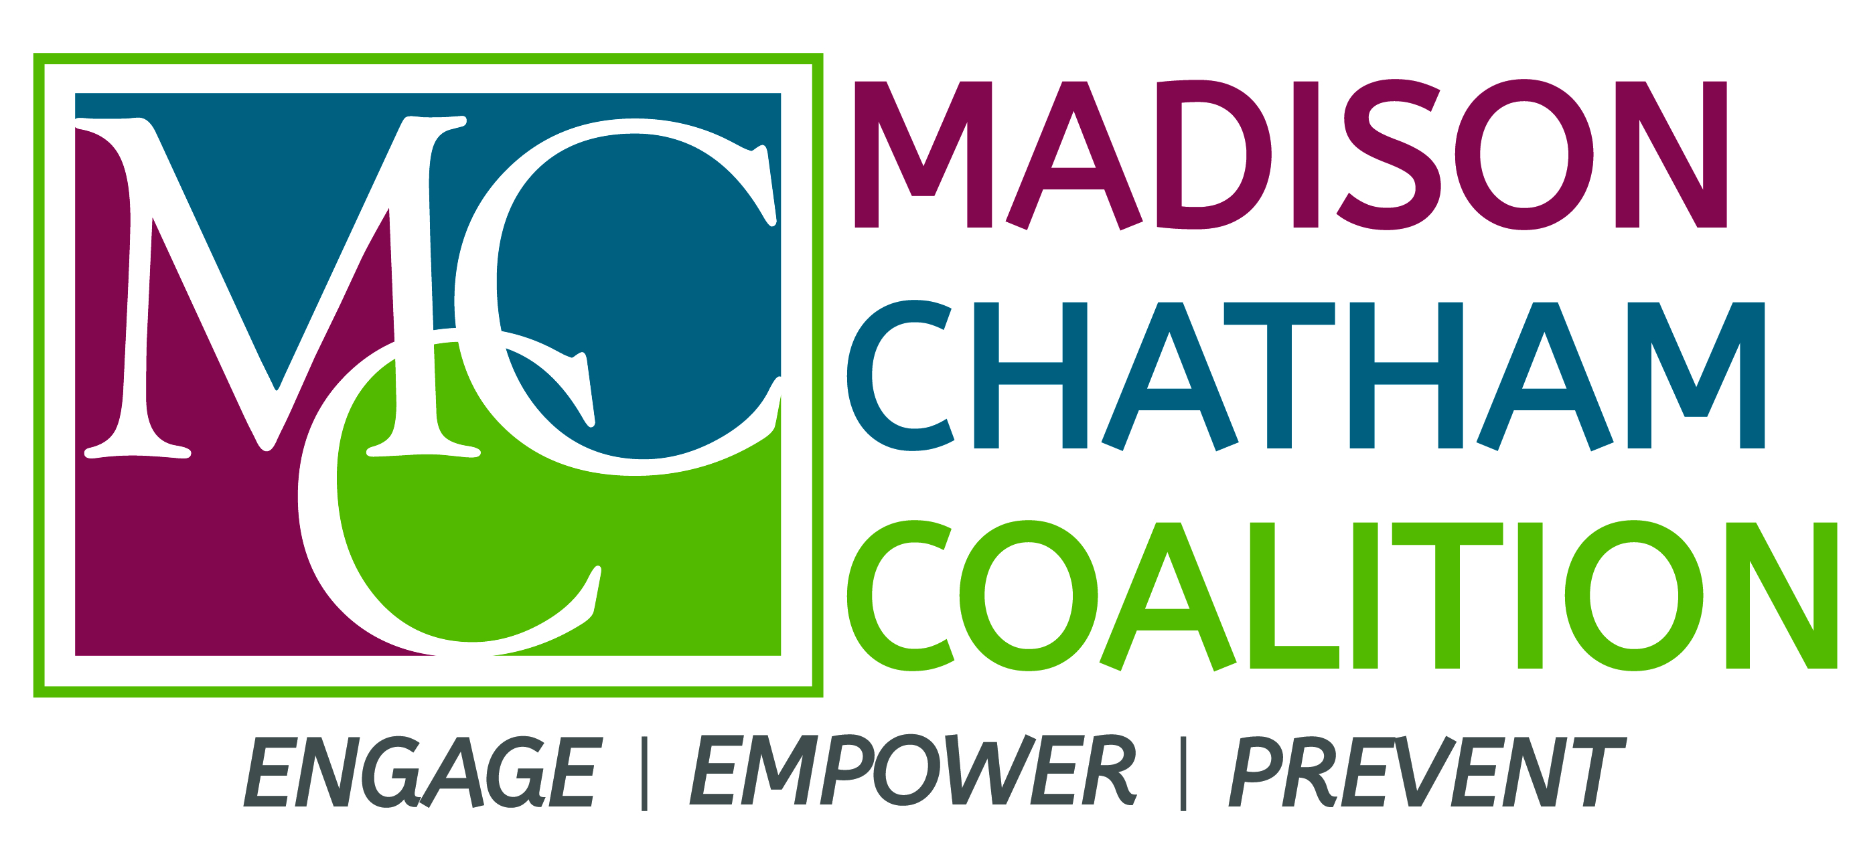 **Facebook: @madisonchathamcoalition**

**Twitter: @MC_Coalition**

**Instagram: @MC_Coalition**

**Website: www.madisonchathamcoalition.org**

**Mission**: Prevent and reduce youth substance use and abuse in the communities of Madison, Chatham Borough and Chatham Township through collaboration, education and community-wide change.

**Madison Chatham Coalition Membership Meeting**

**October 19, 2021- 9:30am** *Virtual Zoom Meeting*

**Zoom webinar link:**  
<https://us02web.zoom.us/j/86452780916?pwd=RmROWFFZOTR6alJYdi9HblpSTktkdz09>   
**Meeting ID:** 864 5278 0916   
**Passcode:** 031196

***Poll link to open prior to meeting:*** [***https://pollev.com/allisonbardon312***](https://pollev.com/allisonbardon312)

***9:30- 9:35*** **Welcome and Introductions via chat feature**

***9:35- 9:40*** **Teen Task Force Update (Ella Bogue)**

* CHS Homecoming



* Night of Conversation

***9:40- 9:50*** **MCC Updates (Allison Bardon)**

* National Prescription Take Back Day- 10/23; 10 AM- 2 PM



* Drug Trends Presentation- 10/25- 7:15 PM
* FDU/MCC Planning
* Qualitative Data Collection Plan

***9:50- 10:15*** **Sector Updates (All sectors in attendance)**

***10:15- 11:00* 2021-22 Coalition Goal-Setting using Poll Everywhere**

**Next MCC Meeting: Tuesday, November 16- 9:30 AM**